 | ORIGINAL DATE: 5/2020 | REVISED: 10/2020, 2/2021
 | POLICY NUMBER: 13.3
TITLE: Compassionate Care Visits During COVID-19

Policy: During the COVID-19 pandemic Rocky Knoll will allow compassionate care visits for qualifying individuals. Visits will be approved on a case by case basis by the Interdisciplinary team.

Procedure:

- All individuals wishing to visit the facility will contact Social services. Social services will then bring the request to the Interdisciplinary team for approval.
- Once approved for compassionate care visits, Social services will update the residents Profile in Point Click Care under “Custom Information” and “Compassionate Care Visits Allowed”
- Example:
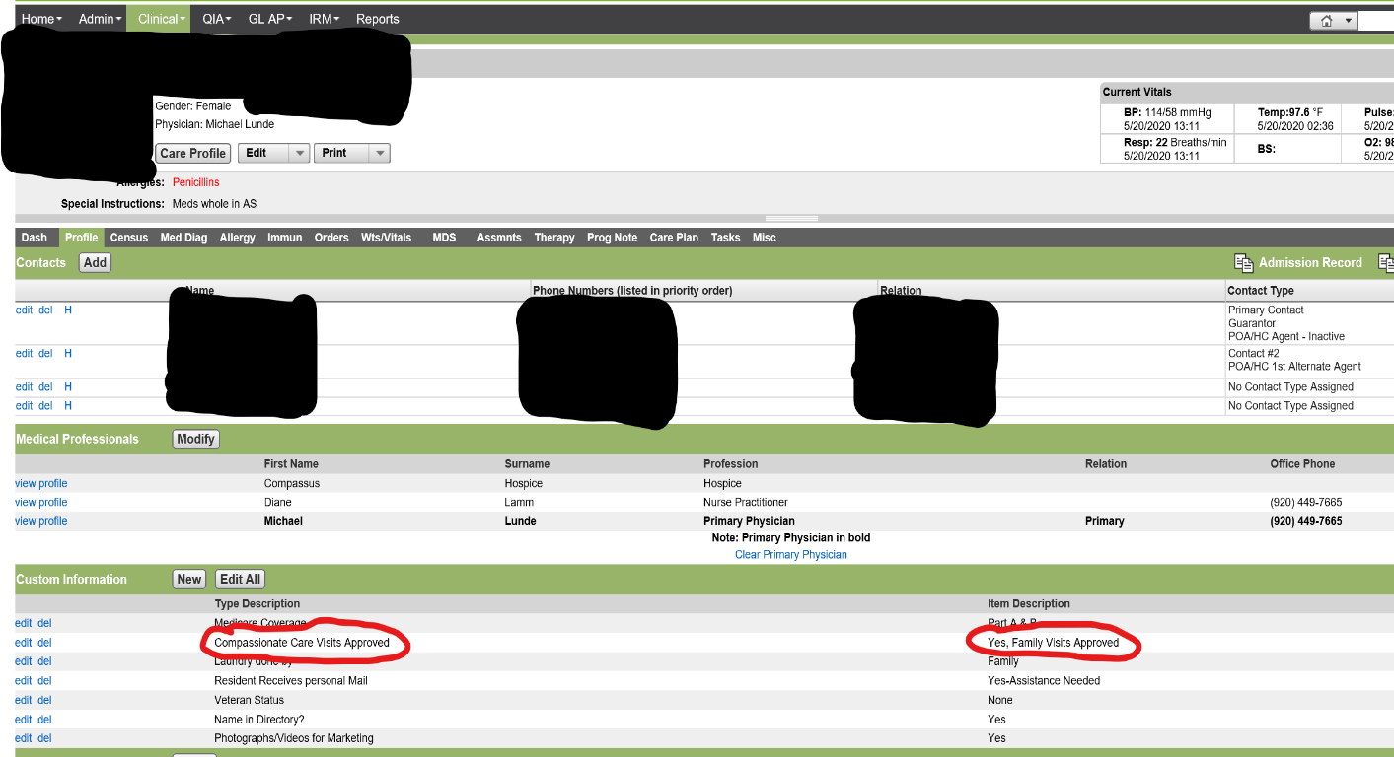
- Please note that in order to receive compassionate care visits, residents (or their representatives) must give consent to be tested for COVID-19 if there is a need as determined by the IDT and or it is recommended by Public Health.
- If a resident or the unit they reside on is on isolation or quarantine, compassionate care visits may be put on hold, as determined by the IDT.

- If the initial visit occurs Monday through Friday during business hours of 8:00 a.m. to 4:30 p.m., visitors will be met at the A-1 entrance by the Area Nurse Manager, Social Services, or an appointed designee. If the initial visit occurs after hours, on the weekends, or on a holiday, visitors will enter/exit through the B-5 door and be keyed into and out of the facility by Rocky Knoll staff. Visitors will be screened for symptoms of illness and will be provided with education on:

  - Proper PPE usage
    - A new surgical mask and gloves must be put on upon entry into the facility and worn during the entire visit
    - A reusable gown must be put on upon entry into the facility and worn for the length of the visit. Once the visit has ended, and prior to exiting the facility, the gown is to be placed in the appropriate hamper located by the exit door(s).
    - Goggles or a face shield must be put on and worn upon entry into the facility and worn during the entire visit. It is to be removed only when the visit has ended and prior to exiting the facility. It can be placed into the bin for sanitization located by the exit door(s)
  - Proper hand hygiene, respiratory hygiene and cough etiquette
  - Restricting movement only to the resident’s room when in the building visiting
  - Limit interaction with others in the facility
  - Limit surfaces touched
  - Limiting the length of the visit as much as possible
  - Understanding and complying to this policy
  - Visitor will sign the education form and agree to follow the procedures

- Upon future visits to the facility the A1 entrance can be used for visits that occur Monday through Friday during business hours of 8:00 a.m. until 4:30 p.m. During business hours visitors do not need to be escorted to and from a resident’s room.

- The B-5 entrance is to be used for after-hours, weekend, and or holiday compassionate care visits. The visitor will press the “Assistance” button at the B-5 entrance and wait for facility staff to meet them at the door. Staff will verify visitor has received initial education, verify the sign in/screening process is completed and escort them to the resident’s room. When ready to leave, visitors must notify staff, who will then escort them back to the B-5 door to sign out.

- Upon entering the facility, approved visitors will be required to complete the screening process:

  - A surgical mask will be put on immediately upon entering the facility and kept on until exiting the facility.
  - Social distancing will be maintained while screening in and out
  - Upon entrance, visitors will sanitize their hands with Alcohol Based Hand Rub
  - Visitors will find the form with a header labeled “Compassionate Care Visits”
  - Visitors will fill in one line on the form with: Date, Time In, Signature, Phone Number, Who You’re Visiting, Temp In, Temp Out, and Time Out.

    - Visitor signature on the form confirms the following:
- I am feeling well today
- I am not experiencing a temperature >100.0 °F OR cough, shortness of breath, body aches, sore throat, chills or new loss of taste or smell
- I have not been in contact with a confirmed diagnosis of COVID
ii. Temp In
- Visitor will take their temperature as previously instructed, and record
their temperature in the “Temp In” column
- If visitor’s temperature reads > than 100.0°F they will not be allowed to visit
  - After taking temperature, visitor will again sanitize their hands with Alcohol Based Hand Rub provided at the sign-in stations

  - At the end of their visit, prior to leaving the building, visitors will take their temperature and note the time they are leaving and record it under “Temp Out” and “Time Out” on the same line they initially completed and signed upon entering the facility.

- Residents who are approved for compassionate care visits and are not on quarantine, isolation, or suspected of having COVID-19 can be escorted outside by their visitor(s). Outdoor compassionate care visits are available Monday-Friday 9:00-3:30. The procedure to follow is below:
  - The visitor(s) must complete the screening in process and put on the required PPE before escorting a resident outside.
  - Once on the unit, the resident or visitor must notify staff and sign out before leaving, and sign in upon returning. The sign in/out clipboard is located at the nurse’s station.
  - The resident must wear a face mask when traveling off their unit, and anytime they are within six feet of another individual.
  - Visitors must keep the required PPE on for the duration of their visit both indoors and outdoors.
  - Residents and visitor(s) must practice social distancing by staying six feet apart from others outside, there is no congregating allowed.
  - Designated Entrance and Exit access areas per unit are as follows:
    - Woodland Village: Woodland Village Patio
    - 1 North: 1 North Patio
    - 1 West: Administrative A1 Entrance/Exit or B1 Entrance/Exit
    - 2 North: Administrative A1 Entrance/Exit or B1 Entrance/Exit
    - 2 West: Administrative A1 Entrance/Exit or B1 Entrance/Exit
  - Residents and visitors are not to deviate from their path to and from their designated entrance and exit outdoors, and cannot sit at the B5 entrance.

- Rocky Knoll reserves the right to check the camera’s located throughout the grounds of Rocky Knoll to ensure the safety of the residents and visitors, as determined by the Interdisciplinary team.

- Compassionate care visits that occur in the building are only to occur in a resident’s room.

- A resident that is approved for outdoor independent outings and not for compassionate care visits may independently go outdoors. They may not have friends/family visit them when they are outside.

- By signing the “Visitor Education” form and or the “Compassionate Care Visitors” sign in sheet, it signifies that you received education, have read and understand the guidelines in this policy and agree to follow them. Failure to abide by the guidelines in this policy can result in a loss of privileges.

- This policy may be revised as COVID-19 infection control restrictions and guidance evolves.

